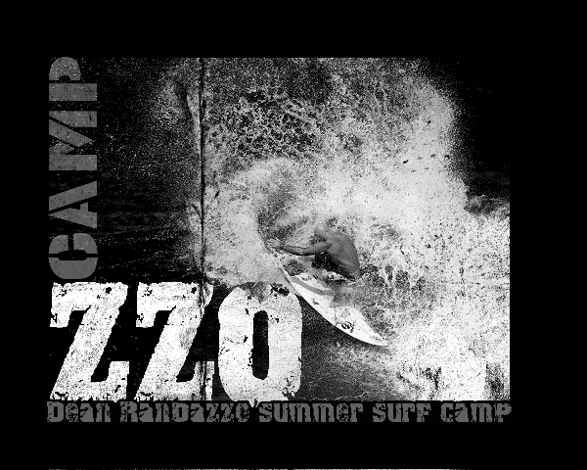

Randazzo Surf Camp Registration Form

For specific camp information call 732-825-SURF or go to www.RandazzoSurf.com

Please print form and email or mail back with payment (separate forms for each child)

Child’s name _________________________ DOB__________________ Grade ____

T-shirt Size (circle one) child: Sm M L adult: XS Sm M L

Parents’ names _________________________________________________________

Address _____________________________________ City _____________________

State ______ Zip ________________ * Email Required ________________________

Phone (h) ____________________________ Phone (w) _______________________

Emergency Contact (Name & Phone) 1) _____________________________________

2) _____________________________________

People Authorized to pick up child: _________________________________________________
Allergies/medications:____________________________________________________________

Medical conditions / special needs__________________________________________________

How did you hear about this camp? _______________________________________

Cost: After July 1, 2015

5 Day Camp-- $350/week/child (10% multi-child discount)
3 Day Camp-- $250 (10% multi-child discount)
1 Day Camp-- $100 (10% multi-child discount)
*Use code camp10 when signing up online to receive multi-child discount

Dates: Circle dates you are registering for below!!! Or, write the dates for 3 day

or 1 day camps here:______________________________________________

July 6 – 10 July 13- 17 July 20- 24 July 27 – 31

August 3–7 August 10–14 August 17-21 August 24-28

Amount due:_______________Payment option: Credit Card Check Cash

Parent signature________________________________Date:_____________

*You may pay by mailing a check, credit card online, cash credit or check prior to camp day In Person at the 2nd street beach location. Mailing address: Randazzo Surf, 165 Jordan road, Somers point NJ 08244
Call with any questions Dean 732-825-SURF

