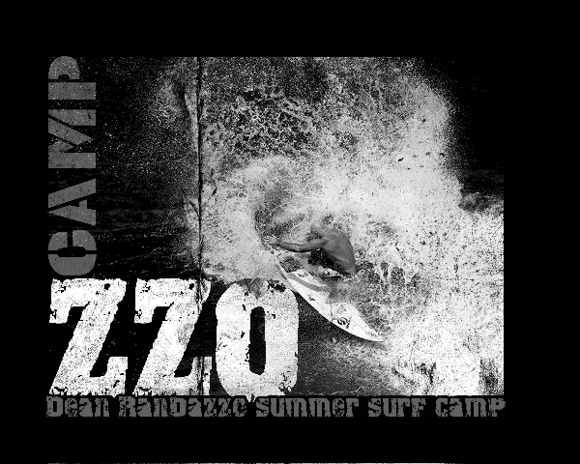
RELEASE OF LIABILITY, ASSUMPTION OF RISK,
WAIVER OF CLAIMS & INDEMNIFICATION AGREEMENT
Notice – By signing this document you may be waiving certain legal rights, including the right to sue. Release and Waiver of Claims; Assumption of the Risk; Indemnification Agreement
In consideration of being allowed to use the facilities and participate in Boardsurfing Instruction/Camps and other activities (collectively the “Activities”) provided by Randazzo Surf, Inc. (the
“Host”), the Participant, and the Participant’s parent(s) or legal guardian(s) if the Participant is a minor, do hereby agree, to the fullest extent permitted by law, as follows:
- TO WAIVE ALL CLAIMS that they have or may have against the Host arising out of the Participant’s participation in the Activities or the use of any equipment provided by the Host (“Equipment”), including while receiving instruction and/or training;
- TO ASSUME ALL RISKS of participating in the Activities and using the Equipment, even those caused by the negligent acts or conduct of the Host, its owners, affiliates, operators, employees, agents, and/or officers. The Participant and his/her parent(s) or legal guardian(s) understand that there are inherent risks of participating in the Activities and using the Equipment, which may be both foreseen and unforeseen and include serious physical injury and death;
- TO RELEASE the Host, its owners, affiliates, operators, employees, agents, and officers from all liability for any loss, damage, injury, death, or expense that the Participant (or his/her next of kin) may suffer, arising out of his/her participation in the Activities and/or use of the Equipment, including while receiving instruction and/or training. The Participant and his/her parent(s) or legal guardian(s) specifically understand that they are releasing any and all claims that arise or may arise from any negligent acts or conduct of the Host, its owners, affiliates, operators, employees, agents, and/or officers, to the fullest extent permitted by law. However, nothing in this Agreement shall be construed as a release for conduct that is found to constitute gross negligence or intentional conduct; and
- TO INDEMNIFY the Host, its owners, affiliates, operators, employees, agents, and/or officers, from all liability for any loss, damage, injury, death, or expense that the Participant (or his/her next of kin) may suffer, arising out of participation in the Activities and/or use of the Equipment, including while receiving instruction and/or training. Photography/Video Release
Participant hereby grants to the Host, its representatives, and employees the right to take photographs/videos of Participant in connection with Participant’s participation in the Activities. Participant hereby authorizes the Host to copyright, use, and publish the same in print and/or electronically. Participant hereby agrees that the Host may use such photographs of Participant for any lawful purpose, including but not limited to publicity, illustration, advertising, and Web content.
Personal Responsibility
The Participant and his/her parent(s) or legal guardian(s) certify that Participant has no physical or mental condition that precludes him/her from participating in the Activities and that he/she is not participating against medical advice.
The Participant and his/her parent(s) or legal guardian(s) understand that Participant’s participation in the Activities is voluntary and further understand that they have the opportunity to inspect the Host’s Equipment and facilities before any participation. The Participant and his/her parent(s) or legal guardian(s) understand that Participant is obligated to follow the rules of the Activities and that he/she can minimize his/her risk of injury by doing so and through the exercise of common sense and by being aware of his/her surroundings. If, while participating in the Activities, the Participant or his/her parent(s) or legal guardian(s) observe any unusual hazard or condition, which they believe jeopardizes Participant’s personal safety or that of others, Participant and/or his/ her parent(s) or legal guardian(s) will remove Participant from participation in the Activities and immediately bring said hazard or condition to the attention of the Host.
To the extent that any portion of this Agreement is deemed to be invalid under the law of the applicable jurisdiction, the remaining portions of the Agreement shall remain binding and available for use by the Host and its counsel in any proceeding. I HAVE READ AND UNDERSTAND THIS AGREEMENT AND I AM AWARE THAT BY SIGNING THIS AGREEMENT I MAY BE WAIVING CERTAIN LEGAL RIGHTS, INCLUDING THE RIGHT TO SUE.
Participant’s Name (Printed): ____________________________________________________________
Participant’s Signature: ____________________________________________________________ Date: ____________________
Parent/Guardian’s Name (Printed): _______________________________________________________
Parent/Guardian’s Signature: _______________________________________________________ Date: ____________________

