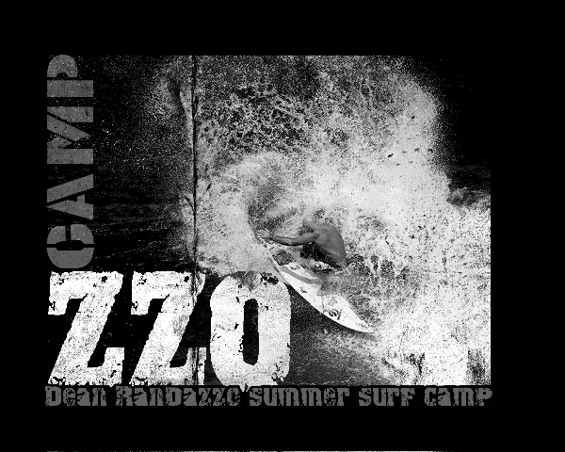

Randazzo Surf Camp Registration Form

For specific camp information call 732-825-SURF or go to www.RandazzoSurf.com

Please print form and email or mail back with payment Email: Randazzosurf@Gmail.com

Child’s name _________________________ DOB__________________ Grade ____ M / F

Childs name___________________________DOB:__________________Grade_____M / F

T-shirt Size:

Parents’ names _________________________________________________________

Address _____________________________________ City _____________________

State ______ Zip ________________ * Email Required ________________________

Phone (h) ____________________________ Phone (w) _______________________

Emergency Contact (Name & Phone) 1) ______________________________________

People Authorized to pick up child: _________________________________________________
Allergies/medications:____________________________________________________________

Medical conditions / special needs__________________________________________________

How did you hear about this camp? _______________________________________

Cost: 2016 North Wildwood Beach

5 Day Camp-- $350
3 Day Camp-- $250
1 Day Camp-- $100

(10% discount when signing up multiple family members and groups)
*Use code camp10 when signing up online to receive multi-child discount

Dates: Circle dates you are registering for below Or, write the dates for 3 day

or 1 day camps here:______________________________________________

Week of: June 20-24, June 27- July 1st, July 4-8, July 11-15, July 18-22,
July 25-29, August 1-5, August 8-12, August 15-19, August 22-26,
August 29-2

Amount due:_______________Payment option: Credit Card Check Cash

Parent signature________________________________Date:_____________

*You may pay by mailing a check, credit card online, cash credit or check prior to camp day In Person at the 2nd street beach location. Mailing address: Randazzo Surf, 165 Jordan road, Somers point NJ 08244
Call with any questions Dean 732-825-SURF

